

Parish Maintenance Contract
Tender Document
2023 / 2026

Sarah Mosedale Parish Clerk
Ethel Wood Community Centre, 129 Coast Road, Pevensey Bay,
East Sussex, BN24 6NS,
Tel: 01323 743 900 / 07849 124319
Email: clerk@pevenseyparishcouncil.gov.uk

- Invitation to Tender: Parish Maintenance Contract 2023-2026

Contract Information

Pevensey Parish Council is inviting tenders for an Approved Contractor(s), to complete ad-hoc maintenance jobs within The Parish of Pevensey. This is likely to be in the order of around 40 hours per year for a period of 33 months from 1st August 2023 until 31st March 2026. The successful Contractor will be self-employed and not be an employee of the Council and will. be responsible for their own insurance cover, income tax, pension and national insurance arrangements.

Three months prior to the end date of the contract, if both parties agree, the contract can be extended by a further year or other period as agreed.

The Contract documents which are attached, comprise the following:

- Invitation to tender.
- List of ad-hoc Works
- Pre-requisites and specification of works
- Standard contract conditions
- Site plans
- Tender form
- Declaration & company details form

- The prices submitted must indicate the hourly rate for carrying out each of the two main elements of the Contract which is for ad-hoc works and emergency call out as listed below.

- Prospective contractors should ensure that they are completely familiar with the nature and extent of their obligations under the contract if their tender is accepted.

- Any queries regarding the interpretation of any part of the contract documents should be addressed to the Clerk by no later than two weeks before the closing date.

- The tender must be submitted on the attached form for it to be considered.

- Prospective contractors should note that the Council is not bound to accept the lowest, or any tender received. The Council’s decision is final, and no correspondence will be entered into on the reasons why a tender has been rejected.

- The successful tender together with the Council’s written acceptance shall form a binding agreement in the terms of the contract documents.

- If having examined the tender documents, you wish to submit a tender you should:

- Fully complete and return the following documents:
- Tender form
- Declaration & company details Form
- Public liability insurance certificate (for at least £5m and ideally £10m)
- Health & safety policy
- Tenderer’s complaints procedure

- Return tenders and all related documentation must be submitted by post no later than 7th July 2023 to the Clerk, Ethel Wood Community Centre, 129 Coast Road, Pevensey Bay, East Sussex, BN24 6NS (Tenders received late will not be considered)

- Please note that the package containing the tender must be clearly marked
‘’Parish Maintenance Contract’’ on the outside.

The documents can either be found on the Parish Councils website or via the Clerk at the above address.

Sarah Mosedale
Clerk to Pevensey Parish Council

Ad-Hoc Work Tasks

The Council is responsible for a number of open space areas and buildings and is looking for a contractor who is able to carry out a variety of maintenance jobs as and when they are required. There is no definitive list of tasks. However, examples of jobs the Council foresee arising are listed below.

- Painting – Repairs to a designed area on both wood and metal surfaces
- Carpentry – Small repairs to fences and gates.
- Signage – Installation of new signage (including mounting attachments) and repairs to existing displays.
- Landscaping – Shrub removal and tidying up existing areas. Planting and removing and watering. Clearance of vegetation from equipment/fencing/bridge etc
- Hardscaping – small repairs and maintenance work on footpaths
- Flying tipping on Council land to be removed
- Litter picking & waste disposal – ad-hoc occasional clearing up after events or unforeseen situations.
- Playground equipment – Maintenance and repairs to existing equipment and removing of any graffiti.
- Ad hoc grass cutting and strimming (areas not covered by main grounds maintenance contractor)
- Building maintenance – minor maintenance, clearance and repairs to various buildings, equipment and outside areas to be carried out as when required. Some emergency work may be required. Minor repairs to street furniture including clearing/removing and reinstating of benches/ notice boards and planters.

The hours of work required are likely to be in the order of around 40 hours per year. These hours may of course alter up or down but are provided as an indication of the total hours likely to be required to be worked under the contract. Emergency hours required are likely to be in order of around 5 -10 hours pre year.

- Pre-Requisites and Specification of works

As a minimum, the contractor must be able to provide a:

- VAT registration number. (if VAT registered)
- Guideline cost with a start date within 5 days of a work request.
- Start date for any approved tasks within 4 weeks of authorisation.
- Response to emergency work requests within 24hrs of notice.
The Contractor should also take note of the following.

- The Contractor must ensure that any staff they may use are adequately trained and provide appropriate safety equipment and clothing to its staff.
- The Contractor must ensure that any equipment and machinery used is in a good state of repair and of a sufficient standard to provide the services under the contract.

- The Contractor shall provide and maintain all tools and consumables (i.e. Bin Bags at their own cost.
- The Contractor shall recharge the Parish Council at cost any additional materials used and provide copies of the receipts. All spend on such materials is subject to prior agreement with the Clerk and/or by quote.
- The Contractor shall be able to respond promptly to Health and Safety matters, including out of normal working hours if necessary. Such tasks include broken glass clearance, making safe damaged play equipment, replacing locks etc.
- The Contractor and their staff will act as additional eyes and ears for the Parish Council whilst on a job for the Council under the contract and report any issues to the Clerk as soon as practicably possible. If Health and Safety issues are identified, then the contractor using due diligence may rectify the matter and inform the Clerk retrospectively if the matter is deemed essential and the Clerk is unavailable.

Standard Contract Conditions

The headings to these conditions shall not affect their interpretation.

Payments and Price
- The hourly rates that comprise the contract price will be reviewed annually in consultation with the contractor.
- Any uplift to the hourly rates that comprise the contract price requested by the Contractor will need to be reviewed at the next available full Council meeting and one months’ notice needs to be given to the Clerk.
Payments will be made by BACS within 30 days of receiving the Contractor’s invoice.

Sites and program of works.

Site details are, but not limited to the following:

- Ethel Wood Community Centre
- Wallsend Road Recreation Ground
- Coast Road Recreation Ground
- Half Pipe play ground
- Additional Areas – the Council may at any time add or remove areas during the period of contract and will notify the Contractor.
- All work will take place between the hours of 09.00 and 18.00 hours, Monday to Friday unless in an emergency.
- If the contractor needs to carry out any works on the weekend, it should be agreed with the Clerk beforehand.
- The contractor will be contactable by mobile telephone throughout the working day.

Termination of Contract
Either party may, without reason, terminate the Contractor, in writing, giving no less than three months’ notice.

Insurance
- The contractor is required to have a minimum of £5 million public liability insurance. A certificate of Insurance to this effect must be produced to the Clerk prior to commencement of the Contract and annually thereafter.
- The Contractor shall indemnify the Council against any claim or proceedings for any injury or damage to any property or persons or animals as a result of negligence, poor workmanship by the Contractor or failure by the Contractor to notify the Council of any action likely to cause injury or damage to a third party. Any damage caused to any property during the performance of this contract by the Contractor must be reported to the Clerk immediately and any costs involved to rectify the damage will be the responsibility of the Contractor.

Health and Safety Law
- The Contractor shall comply with all relevant statutory requirements (including Health and Safety Work Act 1974) at all times in carrying out the services described in this agreement.
- The Contractor shall comply with all relevant legislation relating to the provision of the services under the contract.
- The Contractor is required to undertake their own risk assessment(s) on ad-hoc work tasks as deemed appropriate.

Site Plans

Wallsend Road Recreation Ground – Located off A259 Wallsend Road

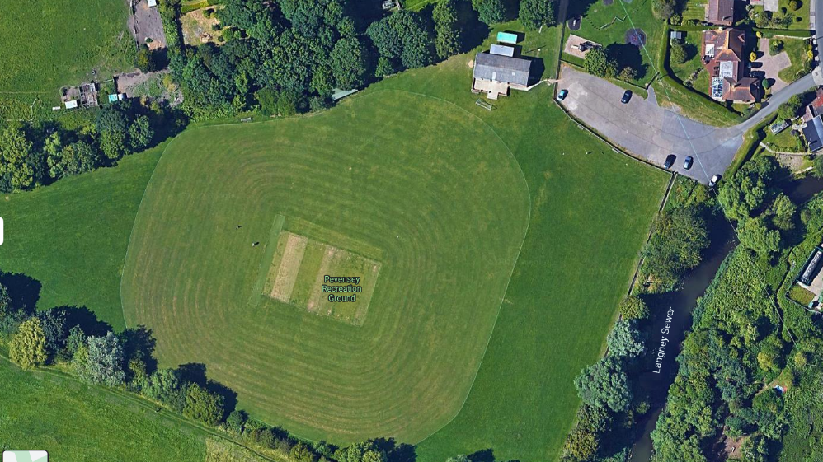

Half Pipe Ground – Located next to Haven Garage off the A259 Wallsend Road

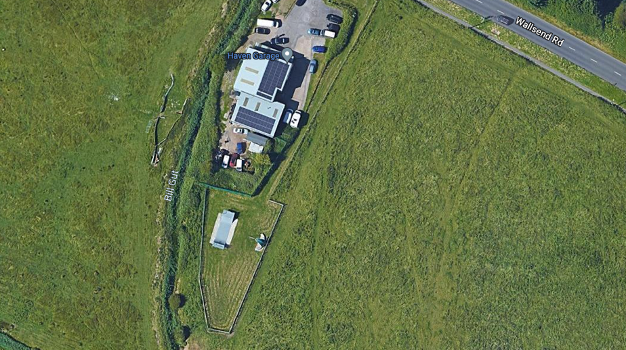

Coast Road Recreation – Located off Waverley Gardens

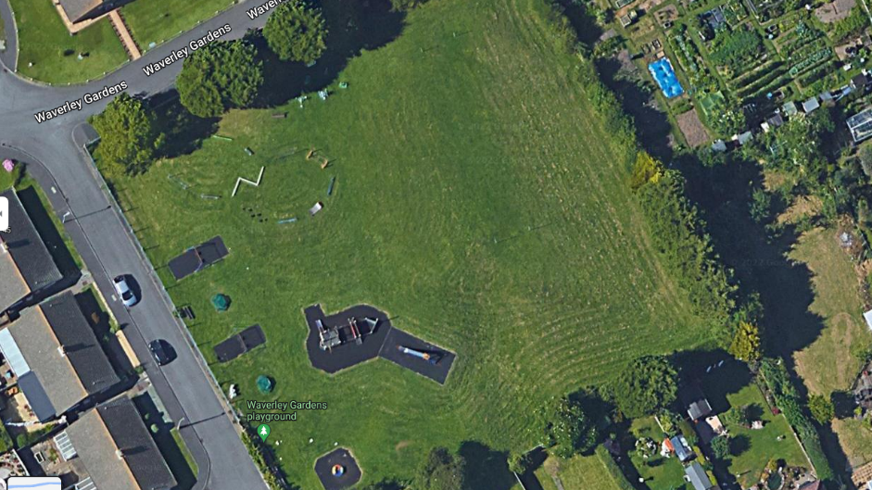

Ethel Wood Community Centre – Located off Coast Road, Pevensey Bay.

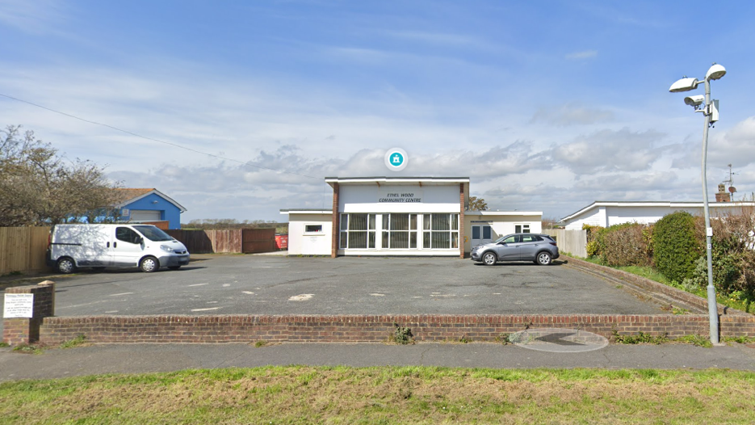

Tender Form

Please complete and sign the Tender Form and Declaration & Company Details Form and send it back to Pevensey Parish Council Office by Friday 7th July 2023.

TENDER RETURN FOR PARISH MAINTENANCE CONTRACT
2023-2026

Service | Rate Per Hour | VAT Applicable Y/N
To carry out duties outlined in the document ‘ad-hoc works task.
To offer Emergency Callout Services on an ad hoc basis

Please complete if you have not been previously used by Pevensey Parish Council in the performance of a similar contract then please provide details of 2 references who can be contacted to provide support for your application.

Referee 1 Referee 2
Name:
Position:
Company Name:
Contact Number:
Contact Email:
Name:
Position:
Company Name:
Contact Number:
Contact Email:

Declaration & Company Details Form – To be submitted to the Council.

Please complete and sign the Tender Form and Declaration & Company Details Form to Pevensey Parish Council Office by Friday 7th July 2023.

I/We agree to complete the works in accordance with the invitation to Tender, Standard Contract Terms, Specification of Works, Schedule of Works and site plans.

I/We understand that Pevensey Parish Council is not bound to accept the lowest or any Tender or part thereof and that the Council will not be responsible for any expense incurred in preparing this Tender.

I/We certify that the amount of the Tender has not been calculated by agreement or arrangement with any other person, firm or company and that the amount of the Tender has not been communicated to any person and will not be communicated to any person until after the closing date for the submission of Tenders.

Company/Business/Personal Name:……………………………………………………………………………………

Business correspondence address:
………………………………………………………………………………………………………………………………………………

……………………………………………………………Post Code: ……………………………………………………………….

VAT Reg No. (If Applicable) ……………………………………………………………..

Contacts:

Landline: …………………………………………………………………

Mobile: …………………………………………………………………….

Email: ………………………………………………………………………

By signing and submitting this tender form you agree that you fully understand the commitments and requirements contained therein and, if successful are willing be bound to the contract as expressed therein.

Signed: ……………………………………………….. Print Name: ……………………………………………………………….

Position: ………………………………………………. Dated: …………………………………………………………………..

