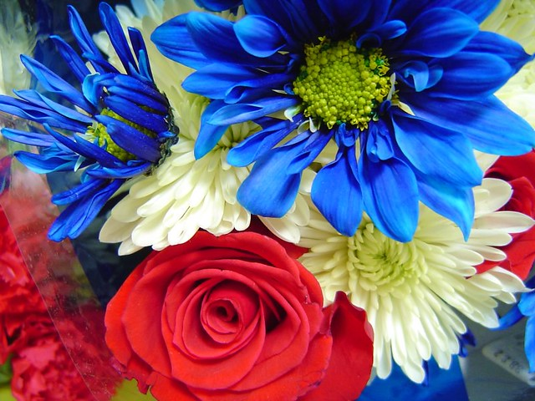
Celebrating the Queen’s Platinum Jubilee 11 – 15 JULY2022
PEVENSEY PARISH COUNCIL
VILLAGE IN BLOOM
11

VILLAGE IN BLOOM 2022

(CLOSING DATE FRIDAY 08 July 2022)

CATEGORIES: A. Best Front Garden
This Photo by Unknown Author is licensed under CC BY-NC
B. Best Container/Hanging basket
C. Best Coastal Garden (Sea side)
D. Best Community Garden

NAME:
ADDRESS:
TELEPHONE NUMBER
EMAIL ADDRESS (if applicable)
CATEGORY FOR ENTRY:

Entry forms to Shirley Clark, Serennu, Eastbourne Avenue, Pevensey Bay BN24 6AS sscgypsy@hotmail.com 01323 769236
or
Pevensey Parish Council, Ethel Wood Community Centre, Coast Road, Pevensey Bay
BN24 6NS clerk@pevenseyparishcouncil.gov.uk

